1. Open the MobaXterm and insert information to connect to AWS

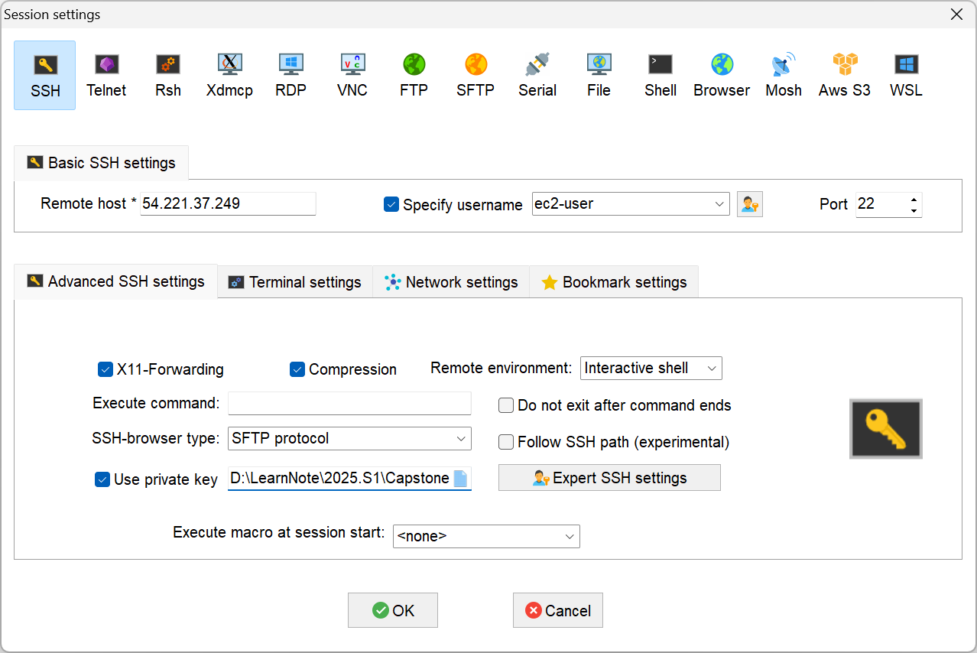

Remote host: AWS endpoint

Specify username: username

User private key: key for login

1. GUI of MobaXterm

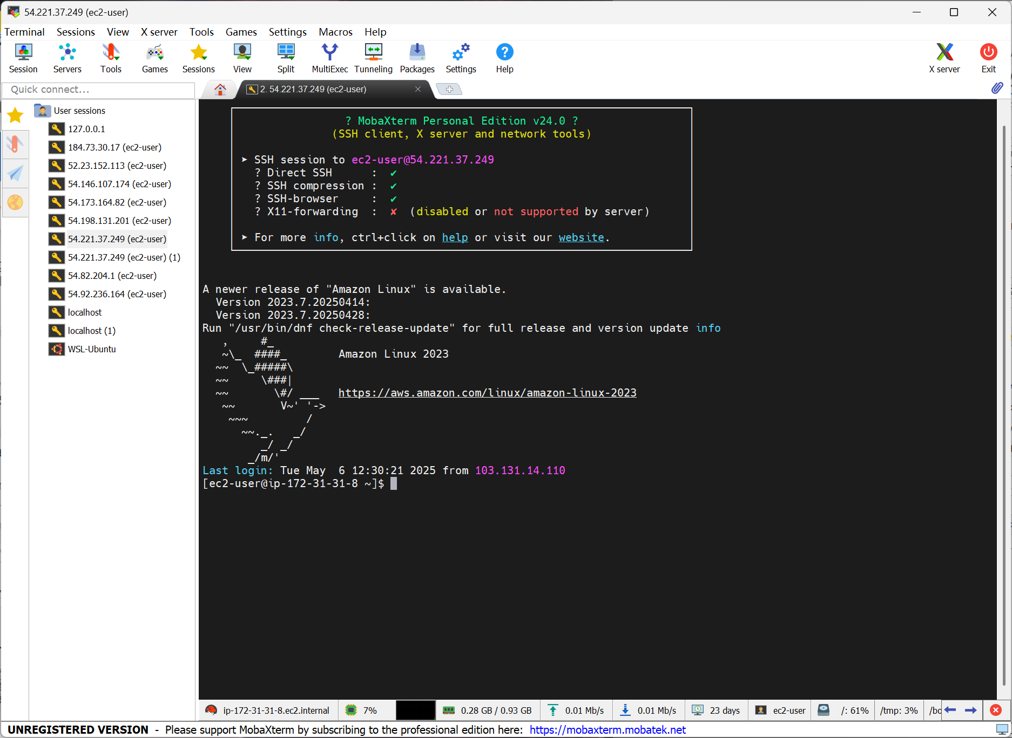

Use command to operate AWS files.

Use the left folder management part to upload or update files by dragging and dropping.

1. Modify the file under the cache to ensure it connects to the AWS Redis service and MongoDB service



1. Upload the redis_cache_service_schedule.py file to the services/cache/ directory
2. Run the redis_cache_service_schedule.py using following command:



1. The result of the running the above command:

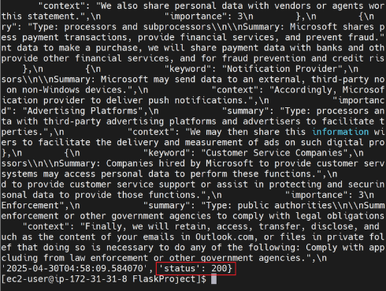

1. The result of the local Redis running is same as the result from the AWS terminal

Using Apifox to mook frontend to active service and success:

Upload file to the AWS and test running success:

